NESTJS assignment

Nest JS API to get the weather by the city name. We are fetching the weather info from a third-party API available on <https://www.weatherapi.com/>

Prequisites:

Understanding of the <https://www.weatherapi.com/> working.

First it searches for the city and returns the details of the city as the response.

URL: <https://www.weatherapi.com/weather/search.ashx?q=mumbai>

Response:

[{"id":1125257,"name":"Mumbai","region":"Maharashtra","country":"India","lat":18.98,"lon":72.83,"url":"mumbai-maharashtra-india"}]

Based on this response it then makes another call to fetch the weather information of that city using the combination of the city.url and city.id as shown below:

URL: <https://www.weatherapi.com/weather/q/mumbai-maharashtra-india-1125257>

Which returns HTML page displaying the weather information.

SWAGGER URL: http://localhost:3000/SWAGGER

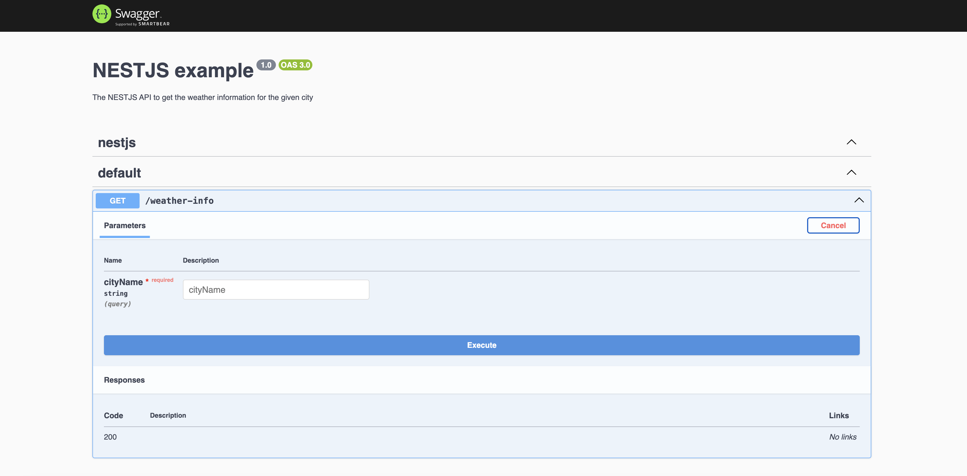

Provide the city name and on click of the execute button this api will first search for the city details and then make another call to get the html response with the weather information as shown below:

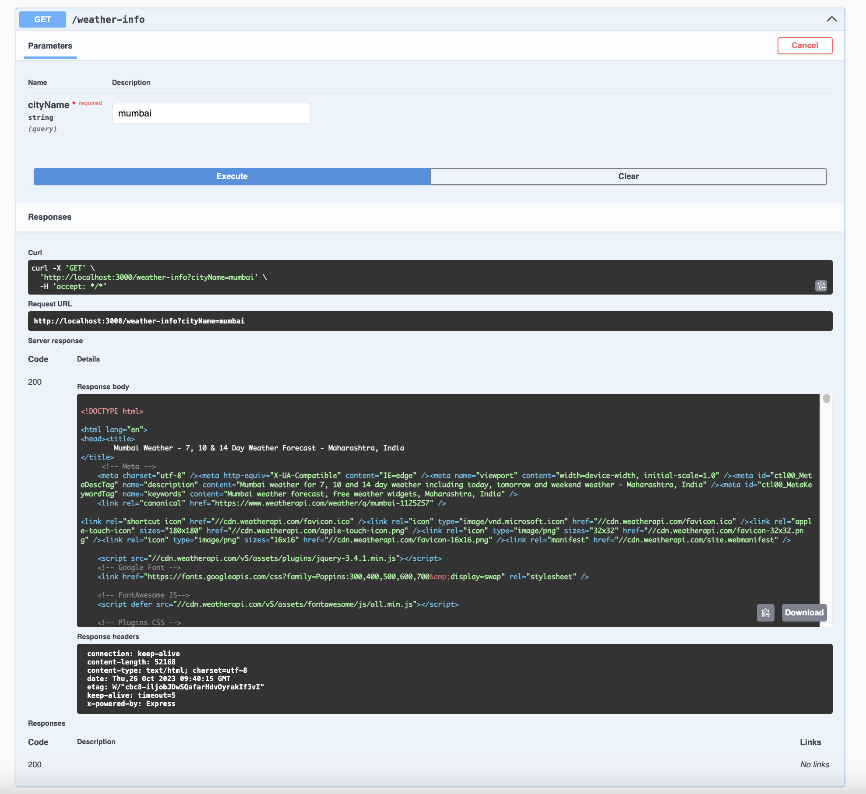

Also we can directly hit the request URL in the browser and it will give us the weather details as shown below: 